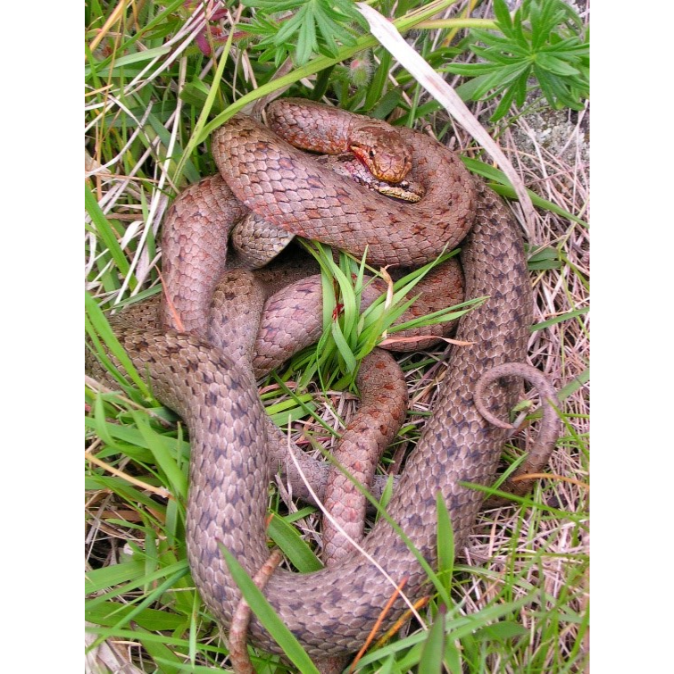
Figure 1. Neck biting during mating attempt on 29th May 2003 at Mølen, Larvik. The female ended up quite bloody and escaped when disturbed by the photographer. This was during the common spring mating period for smooth snakes. Photo: Trond Baugen.

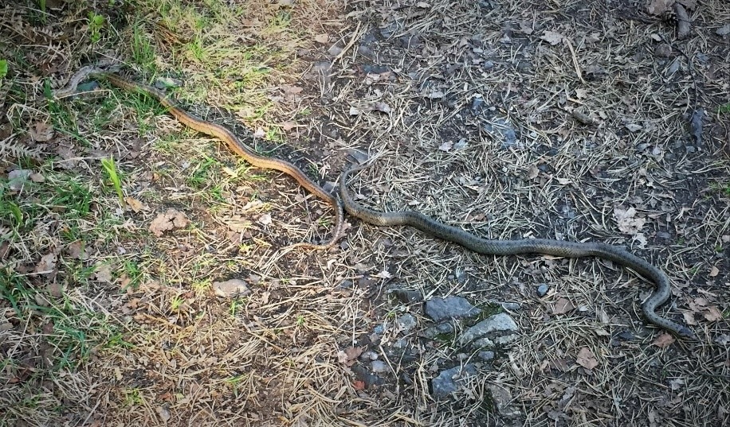
Figure 2. Copulating smooth snakes in Rykkin, Bærum near Oslo on 14th May 2018, which was during their normal spring mating period. No neck-bite observed. Photo: Otto Munthe-Kaas.

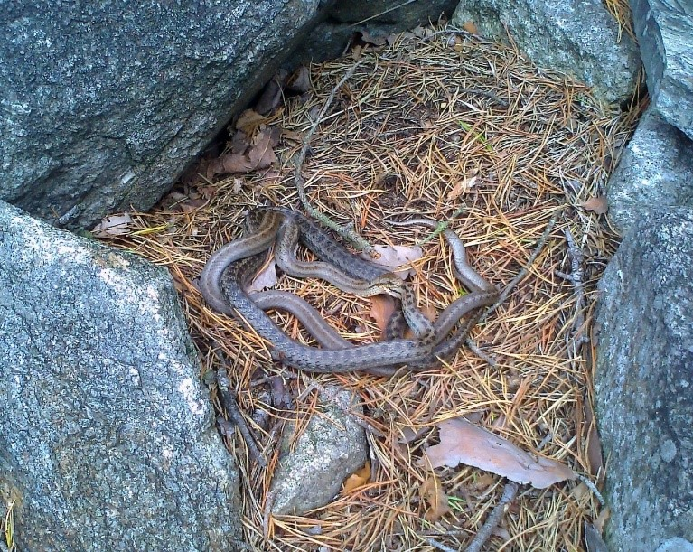
Figure 3. Autumn mating 29th August 2014 in Sandnes, Rogaland, south-western Norway. Neck biting here has resulted in that the male has the head of the female in his mouth. Photo: Gro Pedersen.

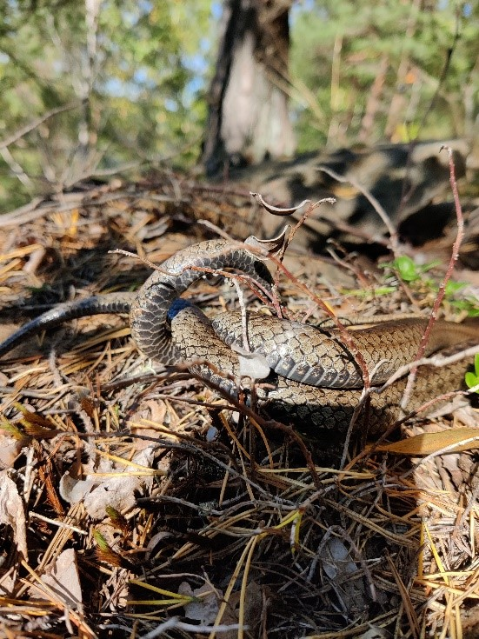
Figure 4. Autumn mating on 16th September 2020 near Moss in south-east Norway. Photo: Geir Hermansen.

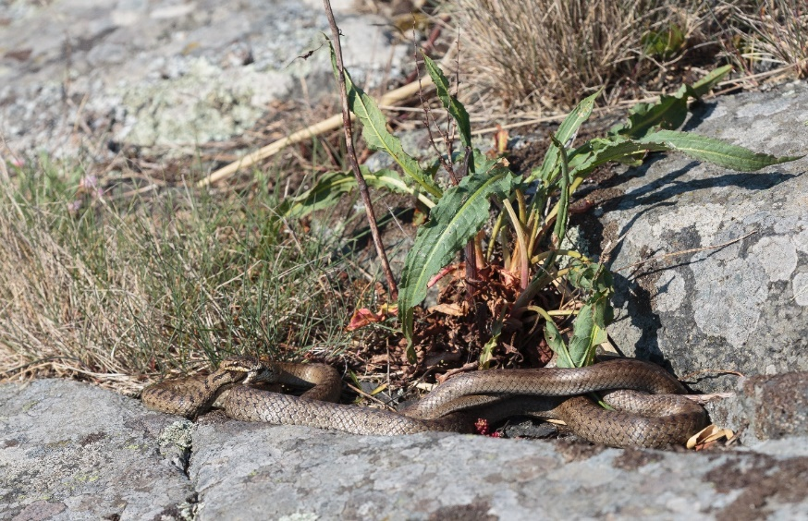
Figure 5. Smooth snake mating at Nevlungstranda, Larvik, Norway on 30 April 2021. Male bites the female’s head. Photo: Ståle Knutsen.

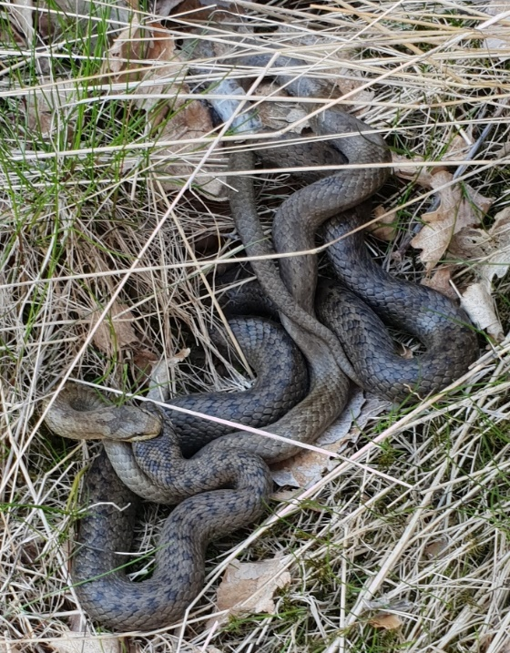
Figure 6. Smooth snake mating in Kristiansand, southern Norway, on 1 May 2021. Male bites females head. Photo: Beate Strøm Johansen.

